**FINAL REPORT**

**Capstone Project - The Battle of Neighbourhoods**

# INTRODUCTION:

**British Columbia** (**BC**) is the westernmost province in Canada, located between the Pacific Ocean and the Rocky Mountains. With an estimated population of 5.1 million as of 2020, it is Canada's third-most populous province. British Columbia is the most diverse province in Canada; as of 2016, the province had the highest proportion of visible minorities in the country. The five largest pan-ethnic groups in the province are Europeans (64%), East Asians (15%), South Asians (8%), Aboriginals (6%) and Southeast Asians (5%). The Chinese and Indian communities form a large part of the newly immigrated population.

In order to service the growing needs of the Chinese and Indian palate, there has been a spurt in the restaurant and catering industry. In particular, we will be exploring Indian and Chinese restaurants in the urban areas of British Columbia.

# PROBLEM:

We will explore the answers to the following questions :-

* List and visualize the urban areas of British Columbia.
* What are the best locations in BC for Indian Cuisine?
* What are the best locations in BC for Chinese Cuisine?
* Plot these locations on the map.
* Common locations for Chinese and Indian restaurants, if any.

# DATA SECTION:

# Ontario and British Columbia have been attracting a lot of young immigrants from different countries, particularly from South East Asia, which has resulted in the establishment of many new restaurants offering Asian cuisine. In particular, we will focus on Indian and Chinese cuisine.

For this project, the following data is required:-

* List of postal codes in urban British Columbia -
  + Data source : <https://en.wikipedia.org/wiki/List_of_postal_codes_of_Canada:_V>
  + Description: This webpage contains the required list of postal codes in urban British Columbia.
* Longitude and Latitude for each postal code
  + Data source: Geocoder API
  + Description: We will use the OpenCage Geocoder for the postal codes to retrieve the longitude and latitude for each neighborhood.

# Indian and Chinese restaurants in each of the neighborhoods -

* + Data source : Foursquare API
  + Description: By using this API, we will get all the venues in each neighborhood. We can filter these venues by category to retrieve Indian/Chinese restaurants only.

# METHODOLOGY:

1. We begin by collecting the zipcodes for urban areas in British Columbia from the following link –

<https://en.wikipedia.org/wiki/List_of_postal_codes_of_Canada:_V>

We can utilize Beautiful Soup and read the first table (containing the zipcodes of urban British Columbia) from the HTML page.

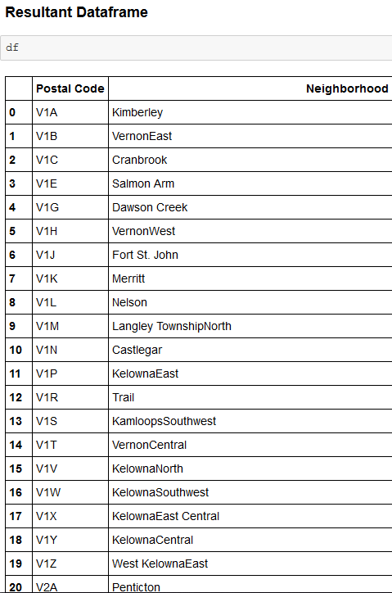

1. We then utilize the Geocoder API for latitude and longitude for each of these zipcodes.

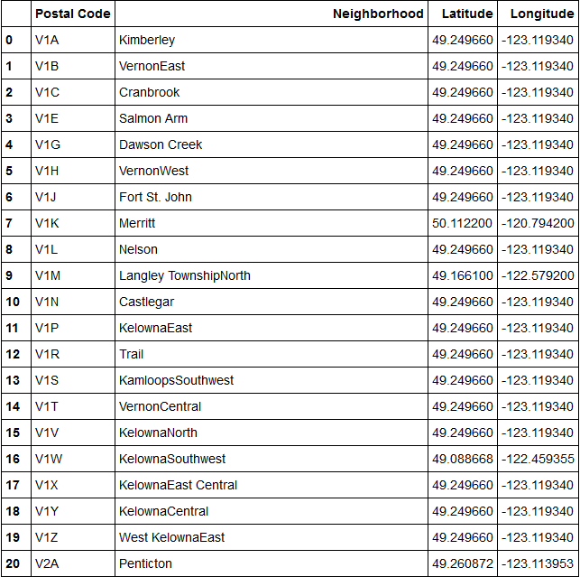

1. Let us visualize these zipcodes on the Folium map.

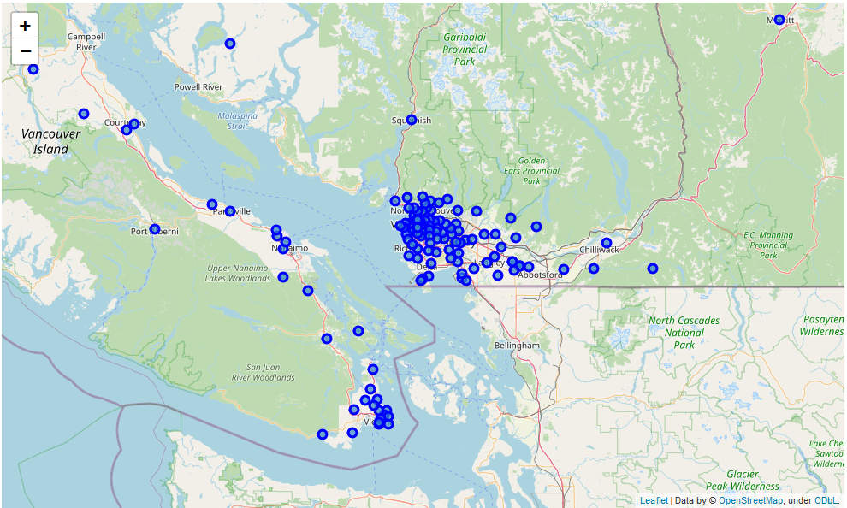

1. We then use the Foursquare API to get number of Indian restaurants for each zipcode, and add them to the dataframe.

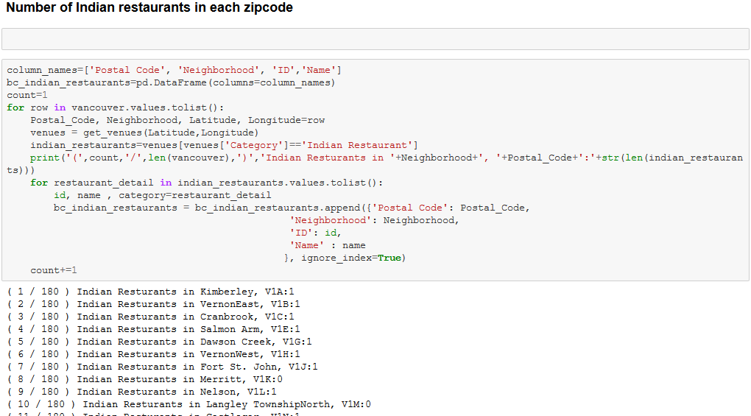

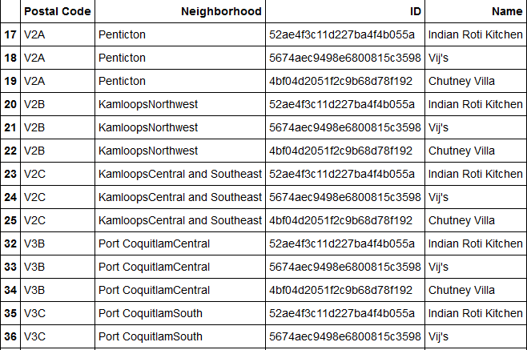

1. We can then use the sandbox/personal Foursquare account to make calls for each restaurant to retrieve likes, ratings and tips for each restaurant.

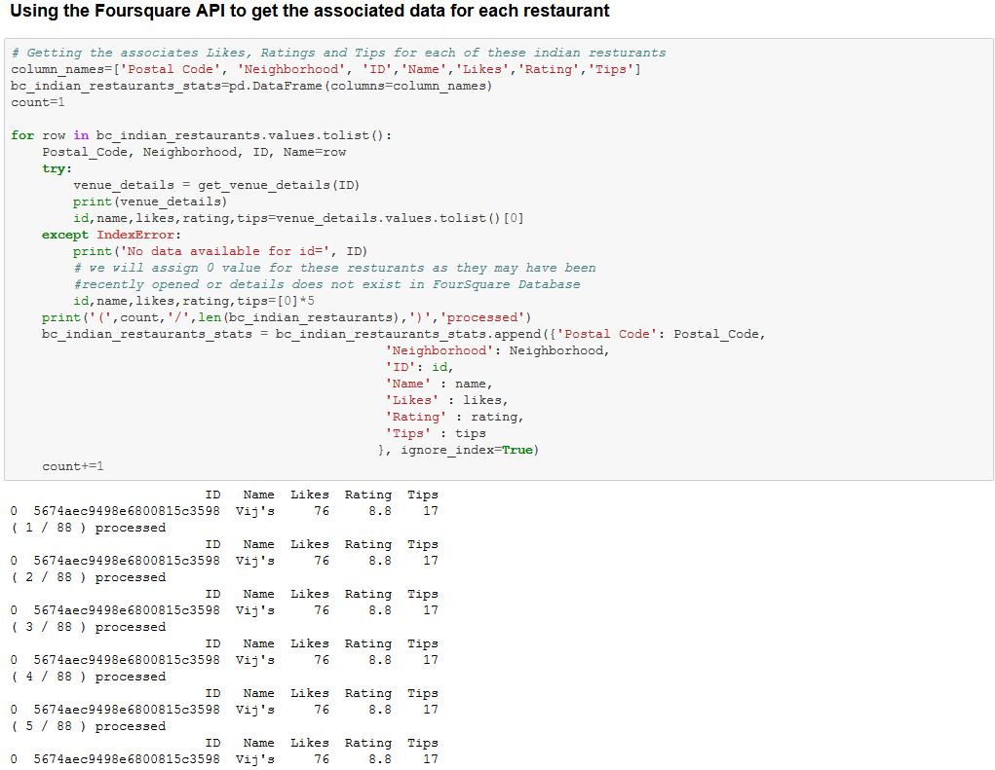

1. We can then get the average rating of Indian restaurants for each zipcode.

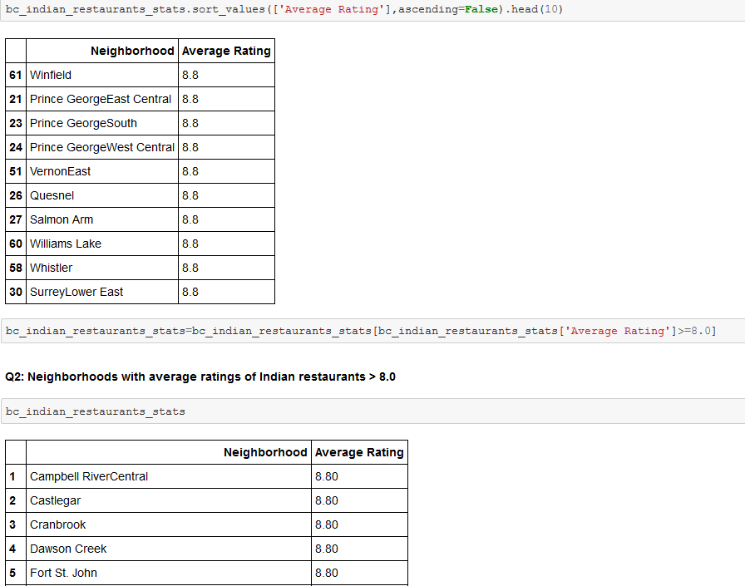

1. We can then make similar observations for Chinese restaurants.

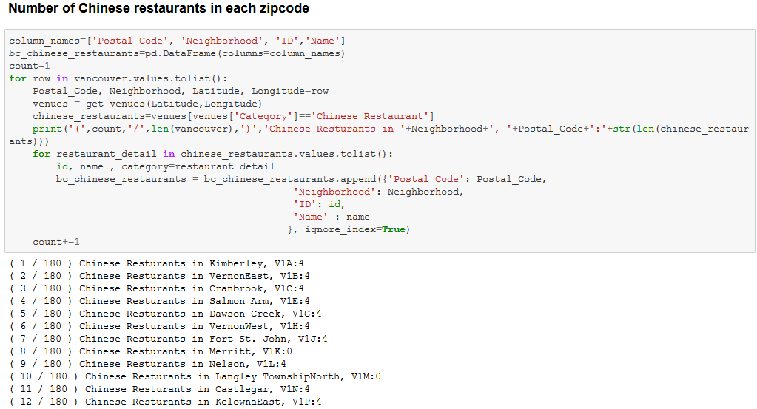

Here are the list of neighborhoods with average ratings of Chinese restaurants > 8.0 –

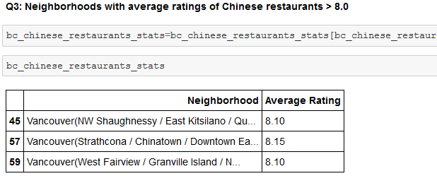

1. We then visualise these average ratings with labels on the Folium map.

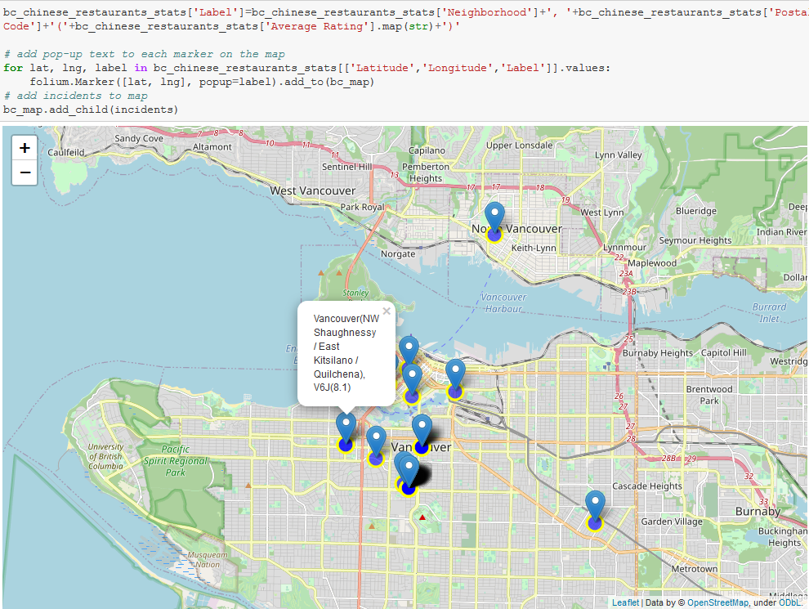

# RESULT:

So now we can answer the questions asked above in the Questions section:

1. The locations that have great Indian restaurants appear to be more widespread. There are also many zip-codes with restaurants that are part of a bigger franchise (for example, Vik’s), hence enjoying the same rating across many different zip-codes. Therefore, there are many areas with Indian restaurants with a rating higher than 8.0. The distribution of restaurants seems to be uniform as well, with equal amount of Indian restaurants in Coquitlam, nearer to Vancouver city, and smaller towns like Kelowna and Penticton.
2. There are more firm favorites for Chinese restaurants. The following areas have the most number of Asian restaurants – V5R -

Vancouver (South Renfrew-Collingwood), V5W - Vancouver (SE Riley Park-Little Mountain / SW Kensington-Cedar Cottage / NE Oakridge / North Sunset) and V5V – Vancouver (West Kensington-Cedar Cottage / NE Riley Park-Little Mountain). But the zipcodes with the highest rated restaurants are V6J – Vancouver (NW Shaughnessy / East Kitsilano / Quilchena), V6A

Vancouver (Strathcona / Chinatown / Downtown Eastside) and V6H

Vancouver (West Fairview / Granville Island / NE Shaughnessy).

1. Looking at the common areas, V6J – Vancouver (NW Shaughnessy / East Kitsilano / Quilchena – appears to be the popular area for highly-rated Chinese and Indian restaurants.

# DISCUSSION:

The Foursquare API does not appear to be the best source for information on Indian restaurants – as the franchise ratings may not reflect the quality of the specific branch in each neighbourhood. There are also too many Indian restaurants located in unique zipcodes with the same rating of 8.8/10, therefore the area with the highest rating was difficult to determine.

# CONCLUSION:

V6J – Vancouver (NW Shaughnessy / East Kitsilano / Quilchena – appears to be the most popular area for highly-rated Chinese and Indian restaurants as per our data – and a great place to open an Asian restaurant!